CURRICULUM VITAE
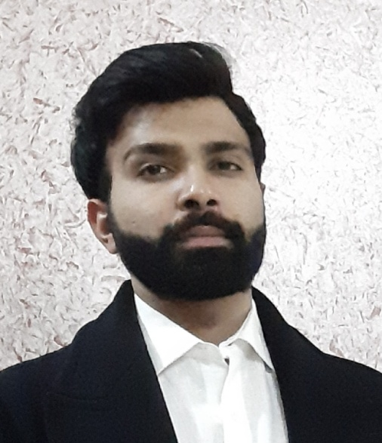
PERSONAL DETAILS:
Particulars | Details
Full Name: | Kushal Dey
Father’s Name: | Mr. Ujjwal Kumar Dey
Date Of Birth: | 15.05.1995
Sex: | Male
Phone Number (Mobile) | +91 9851528366
Email-Id: | kushaldey.dey45@gmail.com; kushal.dey@sxccal.edu
Residential Address:  Permanent Address: | Shanti Chakra Club, Naktala, Netaji Nagar, Kolkata-700040, W.B.  No.1 Bhabanithakur Lane, P.O.- Rajbati, Dist. Burdwan, Pin.713104, W.B.

ACADEMIC QUALIFICATIONS:

Particulars | College/Institute
PhD | St. Xavier’s College Kolkata | Started on 2018
NET | Nov 2017 UGC NET | Qualified as Assistant Professor
M.COM | St. Xavier’s College Kolkata  (2016-2018)
B.COM | St. Xavier’s College Kolkata  (2013-2016)

EXPERIENCE:-

    - Assistant Professor at St. Xavier’s College (Autonomous) Kolkata from 3/1/2019.
    - Guest Lecturer at Heramba Chandra College, Kolkata
    - Part Time Lecturer at St. Xavier’s College(Autonomous) ,Raghabpur campus up to 31/12/2018

Conferences/Seminars/Webinar/FacultyDevelopmentPrograms/WorkshopsAttended:

- Participated in the “Three day Workshop on Advanced Econometric Techniques &Application” held between 11th March , 2019 and 15th March, 2019 at St. Xavier’s College organized by the faculty of Economics, Department of Commerce.

- Participated in the Seven- day Faculty Development Programme on Business Studies held from 20th May to 26th May 2019, organized by Departments of Commerce & Management Studies in collaboration with Department of Commerce, University of Calcutta.

- Participated in 7-day UGC Approved National Workshop on “Quantitative Research Methodology (using SPSS-AMOS-iThenticate) organized by Department of Commerce and Management Studies, St. Xavier’s College (Autonomous), Kolkata held from 8th to 17th August, 2019

- Presented a paper in International Conference on Emerging Perspectives in Commerce, Economics, Environment and Management organized by Department of Commerce and Management Studies, St. Xavier’s College (Autonomous) Kolkata, held on 13th – 14th September, 2019.

- Participated in One Day Faculty Development Programme on “Applications of Finance Lab in Research” organized by Department of Commerce, St. Xavier’s College (Autonomous) Kolkata, held on 18th December 2019

- Attended the Faculty Development on Mindful Leadership “Invincible Wisdom in the Age of Artificial Intelligence” organized by the St. Xavier’s College (Autonomous), Kolkata in association with Indian Institute of Management Kozhikode held on 20th February 2020.

- Presented a paper in a two day international conference on, Emerging issues in Finance and Banking organized by Department of Commerce, Surendranath College, held on 27th -28th February, 2020.

- Participated in a national webinar on “AI- Driven Marketing in Post-COVID Era” organized by Department of Commerce, Evening , Shri Shikshyatan College, Kolkata on 18th June,2020.

- Participated in a webinar on “The NextGen and business education: The Challenges for the teaching Community” organized by Indian Institute of Contemporary Management and Research held on 23rd June, 2020.

- Participated in a webinar on “Future of Banking” organized by Acasia Global held on 24th June, 2020.

- Participated in a national webinar on “COVID-19 and its impact on Finanacial Markets and MSME” organized by Department of Commerce , New Alipore College, Kolkata held on 28th June 2020.

- Participated in a national webinar on “Pandemics and Natural Disasters: Understanding And Coping” organized by IQAC and Academic Council, St. Xavier’s College (Autonomous) Kolkata, held on 11th and 12th July 2020.

PAPERS PUBLISHED IN JOURNALS:
- Dey, K. An Empirical Study Of The Factors That Affects The Exchange Rate Of India (2007-2016), IRJME, Vol. 5(8).AARF, August 2018, ISSN: 2349-0314, IF-5.671.
- Dey, K. Paradigm Shift Of Approaches With Regard To Treatement of Change In Method Of Depreciation: A Theoretical Approach, IRJMC, Vol. 5(8).AARF, August 2018, ISSN: 2348-9766, IF-5.564.
- Shah, Dey, “Maruti Sizuki & the Indian Automobile Industry: The shift from production break down to break through sales”, Vol. 1, Innovative Practices in a VUCA world,2020, ISBN:978-93-89657-14-2.

KUSHAL DEY

