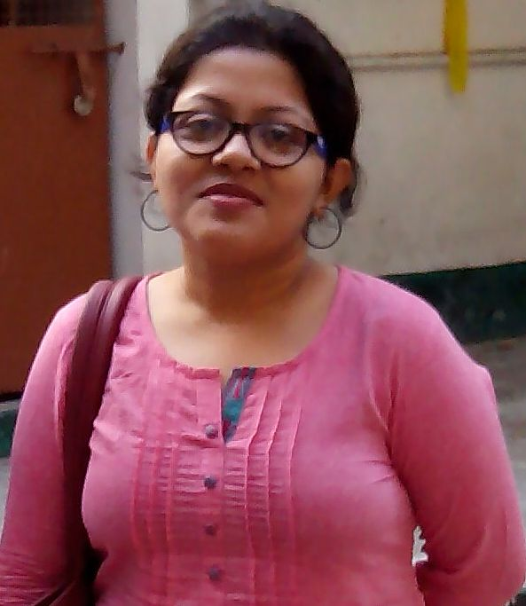SARODIYA DUTTA
DEPARTMENT: BCOM EVENING- ACCOUNTING AND FINANCE
DESIGNATION:PROFESSOR IN CHARGE (SINCE JULY 2019);
ASSISTANT PROFESSOR
QUALIFICATION: MCOM; MPHIL;PGDBA.
DATE OF JOINING PRESENT COLLEGE- 1ST FEBRUARY 2016.
TOTAL YEARS OF TEACHING EXPERIENCE: 12 YEARS 8 MONTHS (AS ON 31.7.2020)
AREA OF RESEARCH- MICRO, SMALL AND MEDIUM ENTERPRISES
EMAIL- sarodiyadutta@gmail.com
Sarodiya Dutta started her teaching career with an ISC School and after that, she had worked with various undergraduate colleges under University of Calcutta as well as in few B-schools under Punjab Technical University, Sikkim Manipal University and Lovely Professional University. She had done her schooling from St. Joseph Convent School (Mosaboni) and Loreto (Bowbazar). She completed her M.Com and Mphil from University of Calcutta and PGDBA from Symbiosis, Pune. She has also qualified SET. She is pursuing her doctoral work under Business Management Department, University of Calcutta since December, 2018.
Meanwhile she had participated in several seminars, workshop and webinars during her career. Her teaching experience is supplemented by various administrative duties performed during teaching in various colleges. She had also completed her Refresher Course conducted by Swayam (MHRD) in the year 2020.

